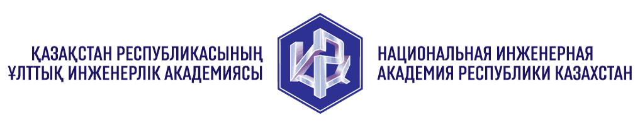 |  |  | 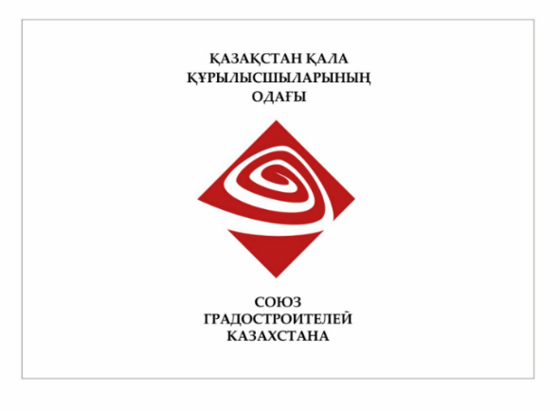

INFORMATION LETTER

Dear colleagues!

Welcome to KAZGORDAY 2025, the V International Research and Practice Conference, dedicated to the 95-th anniversary of the design business origin in the Republic of Kazakhstan to be held on 22-23 May 2025 in Almaty (Kazakhstan) under the auspices of the National Engineering Academy of the Republic of Kazakhstan, National Association of Designers of the Republic of Kazakhstan, Union of Architects of the Republic of Kazakhstan, Union of Urban Planners of the Republic of Kazakhstan.

Subject matters of the Conference:
1. Architecture and urban planning: sustainable urban development, priority trends in urban and land-use planning, social environment, higher quality of life sustenance
- trends in urbanization processes development: studies and recommendations;
- modern types of populated areas and population distribution systems;
- currently important methods for urban renewal;
- environmental aspects of urban redevelopment;
- successful design proposals for residential developments, community centers and shopping centers, industrial development areas, etc.
2. Conventional and advanced practices of design, construction and operation of buildings and structures, also aimed at mitigating risks of seismic and other hazardous impacts of natural environment
• structural analysis methods for beddings, load-bearing and enclosing structures;
• efficient constructional materials, products and prefabricated structures;
• application of information technologies of new generation;
• project management in architecture, urban planning and construction;
• systematisation and automation of production processes of design and survey contractor.
3. Regulatory framework in architecture, urban planning and construction: efficient legal instruments, advanced models for generation of a system of building codes, best practices in supervision and compliance evaluation
• time-and-cost valuation rating, standardisation, building terminology;
• systems for managing urban development processes;
• protection of historical and cultural heritage under present-day conditions;
• advanced systems and methods for ensuring the quality and safety of construction facilities and construction products;
• currently important rules and standards of self-regulated organisations in the design and construction industry.
Conference attendance certificates will be issued to speakers and contributors to the conference proceedings.
Conference working languages: Kazakh, Russian, English.
The participant registration form shall be completed and returned to conference@kazgor.kz or online registration is available at NORMY.KZ - Регистрационная форма KAZGORDAY 2025 before 31 December 2024.
Conference papers shall be submitted to email address: conference@kazgor.kz before 01 April 2025. Requirements for conference papers execution are available on the website NORMY.KZ - Наши конференции.
The conference papers will be published in the conference proceedings (with LBC, UDC, ISBN). To receive one copy (1 book) of the conference proceedings, a registration fee of 10,000 KZT shall be paid.
Conference address: Almaty, Kazakhstan (Conference venue: TBD and the registered participants will be advised of it later in a separate e-mail).
Travel to the conference, accommodation and other expenses shall be borne by the sending party or conference participants themselves.
Information about the conference is available on the website: NORMY.KZ - Наши конференции.
Contacts: +7 (701) 7662167 - Aidar Konusbayev, Head of Secretariat (aidar.konusbayev@kazgor.kz); +7 (701) 3791619 - Gulfaуruz Issa, Executive Secretary (gulfaruz.issa@kazgor.kz).

Organising Committee

